Homework 2
Ryan Balachandran 10/31/2021
Chapter 6:
#2) Consider the data set shown in the table below
Customer ID | Transaction ID | Items Bought
1 | 0001 | {a, d, e}
1 | 0024 | {a, b, c, e}
2 | 0012 | {a, b, d, e}
2 | 0031 | {a, c, d, e}
3 | 0015 | {b, c, e}
3 | 0022 | {b, d, e}
4 | 0029 | {c, d}
4 | 0040 | {a, b, c}
5 | 0033 | {a, d, e}
5 | 0038 | {a, b, e}

- Compute the support for itemset {e}, {b, e}, and {b, d, e} by treating each transaction ID as a market basket.
There are 10 unique transaction ID’s.
Support of {e} is $\frac{8}{10}=0.8 or 80\%$
Support of {b, d} is $\frac{2}{10}=0.2 or 20\%$
Support of {b, d, e} is $\frac{2}{10}=0.2 or 20\%$
- Use the results in part (a) to compute the confidence for the association rules {b, d}{e} and {e}{b, d}. Is the confidence measure symmetric?
Confidence of {b, d}{e} => $\frac{\left\{e\right\}}{\left\{b, d\right\}}=\frac{0.2}{0.2}=0.1 or 100\%$
- ({e} is 0.2 because of {b, d, e}, the number of times {b, d} appears with {e})
Confidence of {e}{b, e} => $\frac{\left\{b,d\right\}}{\left\{e\right\}}=\frac{0.2}{0.8}=0.25 or 25\%$
No, the confidence measure is not symmetric
- Repeat part (a) by treating each customer ID as a market basket. Each item should be treated as a binary variable (1 if an item appears in at least one transaction bought by the customer, and 0 otherwise).
There are 5 unique Customer ID’s.
Support of {e} is $\frac{4}{5}=0.8 or 80\%$ (Only Customer ID 4 doesn’t have {e})
Support of {b, d} is $\frac{5}{5}=0.1 or 100\%$ (Even though {b, d} may appear separately, we are treating the Customer ID as market baskets. So, if the customer had both {b} and {d} or {b, d} in their basket, we count it)
Support of {b, d, e} is $\frac{4}{5}=0.8 or 80\%$ ({b, d, e} only occurs in Customer ID 3 and 2, but we also count if the Customer ID has {b, d}, {e}, {b}, {d}, {b, e}, or {d, e}. Though we only count it once for any instance.)
- Use the results in part (c) to compute the confidence for the association rules {b, d}{e} and {e}{b, d}
Confidence of {b, d}{e} => $\frac{\left\{e\right\}}{\left\{b, d\right\}}=\frac{0.8}{1}=0.8 or 80\%$
Confidence of {e}{b, d} =? $\frac{\left\{b,d\right\}}{\left\{e\right\}}=\frac{0.8}{0.8}=0.8 or 100\%$
- Suppose S₁ and C₁ are the support and confidence values of an association rule r when treating each transaction ID as a market basket. Also let S₂ and C₂ be the support and confidence values of r when treating each customer ID as a market basket. Discuss whether there are any relationships between S₁ and S₂ or C₁ and C₂.
 | S₁ | S₂ | C₁ | C₂
{e} | 80% | 80%
{b, d} | 20% | 100%
{b, d, e} | 20% | 80%
{b, d}{e} |  |  | 100% | 80%
{e}{b, d} |  |  | 25% | 100%

There is no apparent relationship between S₁, S₂, C₁, and C₂.

#3)
- What is the confidence for the rules 0A and A0? (0 is null set)
The confidence and the support are the same for 0A.
Confidence for A0 is 100% as the null set is always in any set.
- Let C₁, C₂, and C₃ be the confidence values of the rules {p}{q}, {p}{q, r}, and {p, r}{q}, respectively. If we assume that C₁, C₂, and C₃ have different values, what are the possible relationships that may exist among C₁, C₂, and C₃? Which rule has the lowest confidence? S(p$∪$q) => support of p and q. $∪$ = and
C₁ = $\frac{s\left(p∪q\right)}{s\left(p\right)}$ C₂ = $\frac{s\left(p∪q∪r\right)}{s\left(p\right)}$ C₃ = $\frac{s\left(p∪q∪r\right)}{s\left(p∪r\right)}$
$$s\left(p\right)≥s\left(p∪q\right)≥s\left(p∪q∪r\right)$$
C₁$≥$C₂
C₃$≥$C₂
Therefor C₂ has the lowest confidence
- Repeat the analysis in part (a) assuming that the rules have identical support. Which rule has the highest confidence?
$$s\left(p∪q\right)=s(p∪q∪r)$$
$$But s\left(p\right)≥s(p∪r)$$
Thus C₃ $≥$ (C₁ $=$ C₂)
There are two options; 1) all rules have the same confidence
2) C₃ has the highest confidence
- Transitivity: Suppose the confidence of the rules AB, and BC are larger than some threshold, minconf. Is if possible that AC has a confidence less than minconf?
Yes, AC can have a confidence lower than the minimal confidence. It depends on the support items of A, B, and C.
Example:
Minimal confidence = 40%
Support of {A, B} = 50% Support of {A} = 90%
Support of {A, C} = 20% Support of {B} = 70%
Support of {B, C} = 50% Support of {C} = 60%

Confidence of AB => $\frac{50}{90}=0.56 or 56\%>minimal confidence$
Confidence of BC => $\frac{50}{70}=0.71 or 71\%>minimal confidence$
Confidence of AC => $\frac{20}{60}=0.33 or 33\%<minimal confidence$
#4) For each of the following measures, determine whether it is monotone, anti-monotone, or non-monotone (i.e., neither monotone nor anti-monotone).
Example: Support, s = $\frac{σ\left(X\right)}{\left|T\right|}$ is anti-monotone because s(X) $≥$ s(Y) whenever $X⊂Y$.
- A characteristic rule is a rule of the form {p}{q₁, q₂, …, q_{n}}, where the rule antecedent contains only a single item. An itemset of size k can produce up to k characteristic rules. Let $ζ$ be the minimum confidence of all characteristic rules generated from a given itemset:
$ζ$({p₁, p₂, …, p_{k}}) = min [ c({p₁}{p₂, p₃, …, p_{k}}), …
c({p_{k}}{p₁, p₂, …, p_{k-1}})]
Is $ζ$ monotone, anti-monotone, or non-monotone?
$ζ$ is anti-monotone because $ζ$({A₁, A₂, …, A_{k}}) $≥$ $ζ$({A₁, A₂, …, A_{k}, A_{k+1}})

For example, if we compare the values of $ζ$ for {A, B} and {A, B, C}, then:
$$ζ\left(\left\{A,B\right\}\right)=\min\left[ c\left(A→B\right), c\left(B→A\right)\right]=\min\left[\frac{s\left(A,B\right)}{s\left(A\right)},\frac{s\left(A,B\right)}{s\left(B\right)}\right]=\frac{s\left(A,B\right)}{max⁡[s\left(A\right), s\left(B\right)]}$$

$$ζ\left(\left\{A,B, C\right\}\right)=\min\left[ c\left(A→BC\right), c\left(B→AC\right), c(C→AB)\right]=\min\left[\frac{s\left(A,B,C\right)}{s\left(A\right)},\frac{s\left(A,B,C\right)}{s\left(B\right)},\frac{s\left(A,B,C\right)}{s\left(C\right)}\right]=\frac{s\left(A,B,C\right)}{max⁡[s\left(A\right), s\left(B\right),s(C)]}$$
Since the support of (A, B, C) is less than or equal to the support of (A, B), and the max of the support of (A), (B), and (C) is greater than the max of the support of (A) and (B), then $ζ\left(\left\{A,B\right\}\right)≥ζ\left(\left\{A,B,C\right\}\right)$

- A discriminant rule is a rile of the form {p₁, p₂, …, p_{n}}{q}, where the rule consequent contains only a single item. An itemset of size k can produce up to k discriminant rules. Let $η$ be the minimum confidence of all discriminant rules generated from a given itemset:
$η$ ({p₁, p₂, …, p_{k}}) = min [ c({p₂, p₃, …, p_{k}} {p₁}), …
c({p₁, p₂, …, p_{k-1}} {p_{k}})]
Is $η$ monotone, anti-monotone, or non-monotone?
$η$ is non-monotone
For example, if we compare the values of $η$({A, B}) with $η$({A, B, C}), then:
$$η\left(\left\{A,B\right\}\right)=\min\left[ c\left(A→B\right), c\left(B→A\right)\right]=\min\left[\frac{s\left(A,B\right)}{s\left(A\right)},\frac{s\left(A,B\right)}{s\left(B\right)}\right]=\frac{s\left(A,B\right)}{max⁡[s\left(A\right), s\left(B\right)]}$$

$$η\left(\left\{A,B, C\right\}\right)=\min\left[ c\left(AB→C\right), c\left(AC→B\right), c(BC→A)\right]=\min\left[\frac{s\left(A,B,C\right)}{s\left(A,B\right)},\frac{s\left(A,B,C\right)}{s\left(A,C\right)},\frac{s\left(A,B,C\right)}{s\left(B,C\right)}\right]=\frac{s\left(A,B,C\right)}{max⁡[s\left(A,B\right), s\left(A,C\right),s(B,C)]}$$

Since the support of (A, B, C) is less than the support of (A, B), and the max of the support of (A, B), (A, C), and (B, C) is less than or equal to the max support of (A), (B), and (C), then $η\left(\left\{A,B, C\right\}\right)$ can be greater than or less than $η\left(\left\{A,B\right\}\right)$

- Repeat the analysis in parts (a) and (b) by replacing the min function with a max function.
- Let $ζ'$({A₁, A₂, …, A_{k}}) = max[ c(A₁ A₂, A₃,…, A_{k}),…
c(A_{k} A₁, A₃ …, A_{k-1})]

$$ζ'\left(\left\{A,B\right\}\right)=\max\left[ c\left(A→B\right), c\left(B→A\right)\right]=\max\left[\frac{s\left(A,B\right)}{s\left(A\right)},\frac{s\left(A,B\right)}{s\left(B\right)}\right]=\frac{s\left(A,B\right)}{min⁡[s\left(A\right), s\left(B\right)]}$$

$$ζ\left(\left\{A,B, C\right\}\right)=\max\left[ c\left(A→BC\right), c\left(B→AC\right), c(C→AB)\right]=\max\left[\frac{s\left(A,B,C\right)}{s\left(A\right)},\frac{s\left(A,B,C\right)}{s\left(B\right)},\frac{s\left(A,B,C\right)}{s\left(C\right)}\right]=\frac{s\left(A,B,C\right)}{min⁡[s\left(A\right), s\left(B\right),s(C)]}$$
Since the support of (A, B, C) is less than or equal to the support of (A, B), and the min of the support of (A), (B), and (C) is less than or equal to the max of the support of (A) and (B), then the measure is now non-monotone.
- Let $η'$({A₁, A₂, …, A_{k}}) = max [ c(A_{2,} A₃,…,A_{k} A₁),…
c(A₁, A₂,…,A_{k-1} A_{k})]

$$η'\left(\left\{A,B\right\}\right)=\max\left[ c\left(A→B\right), c\left(B→A\right)\right]=\max\left[\frac{s\left(A,B\right)}{s\left(A\right)},\frac{s\left(A,B\right)}{s\left(B\right)}\right]=\frac{s\left(A,B\right)}{min⁡[s\left(A\right), s\left(B\right)]}$$

$$η'\left(\left\{A,B, C\right\}\right)=\max\left[ c\left(AB→C\right), c\left(AC→B\right), c(BC→A)\right]=\max\left[\frac{s\left(A,B,C\right)}{s\left(A,B\right)},\frac{s\left(A,B,C\right)}{s\left(A,C\right)},\frac{s\left(A,B,C\right)}{s\left(B,C\right)}\right]=\frac{s\left(A,B,C\right)}{min⁡[s\left(A,B\right), s\left(A,C\right),s(B,C)]}$$

Since the support of (A, B, C) is less than or equal to the support of (A, B), and the min of the support of (A, B), (A, C), and (B, C) is less than or equal to the min support of (A), (B), and (C), which is less than or equal to the min support of (A) and (B), then $η'\left(\left\{A,B, C\right\}\right)$ can be greater than or less than $η\left(\left\{A,B\right\}\right)$, allowing it to still be non-monotone.

#8) The Apriori algorithm uses a generate-and-count strategy for deriving frequent itemsets. Candidate itemsets of size k + 1 are created by joining a pair of frequent itemsets of size k (this is known as the candidate generation step). A candidate is discarded if any one of its subsets is found to be infrequent during the candidate pruning step. Suppose the Apriori algorithm is applied to the data set shown in table 6.3 with minsup = 30%, i.e., any itemset occurring in less than 3 transactions is considered to be infrequent.
- Draw an itemset lattice representing the data set given in table 6.3. Label each node in the lattice with the following letter(s):
- N: If the itemset is not considered to be a candidate itemset by the Apriori algorithm. There are two reasons for an itemself not to be considered as a candidate itemset: (1) it is not generated at all during the candidate generation step, or (2) it is generated during the candidate generate step but is subsequently removed during the candidate pruning step because one of its subsets is found to be infrequent.
- F: If the candidate itemset is found to be frequent by the Apriori algorithm.
- I: If the candidate itemset is found to be infrequent after support counting.

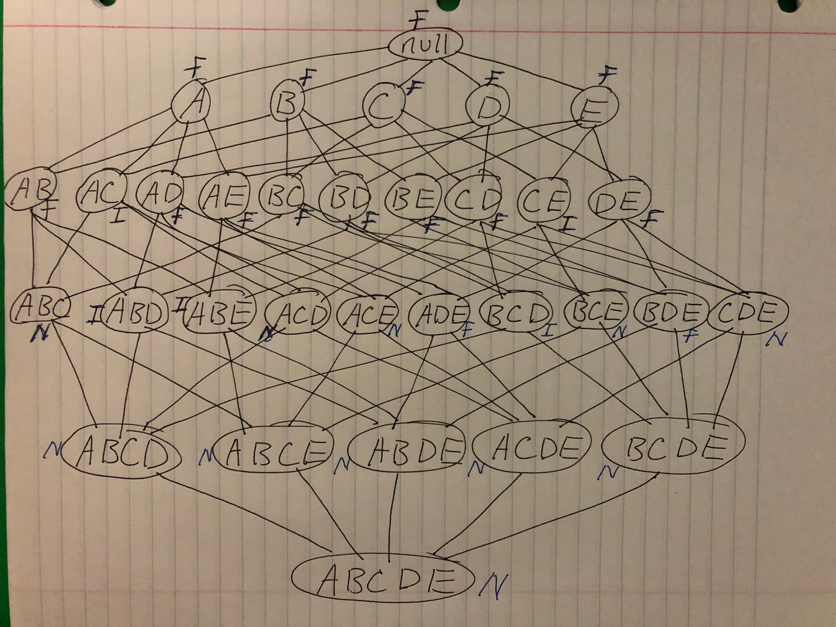
- What is the percentage of frequent itemsets (with respect to all itemsets in the lattice)?
Percentage of frequent itemset = $\frac{16}{32}=50\%$ (including null set)
Total = 32
Frequent itemsets = 16
- What is the pruning ratio of the Apriori algorithm on the data set? (Pruning ratio is defined as the percentage of itemsets not considered to be a candidate because (1) they are not generated during candidate generation or (2) they are pruned during the candidate pruning step.)
Pruning ratio = $\frac{11}{32}=34.4\%$ N = 11
- What is the false alarm rate (i.e, percentage of candidate itemsets that are found to be infrequent after performing support counting?
False alarm rate = $\frac{5}{32}=15.6\%$ I = 5
#17) Suppose we have market basket data consisting of 100 transactions and 20 items. If the support for item a is 25%, the support for item b 90% and the support for itemset {a, b} is 20%. Let the support and confidence thresholds be 10% and 60% respectively.
100 transactions support threshold of 10%
20 items confidence threshold of 60%
- Compute the confidence of the association rule {a}{b}. Is the rule interesting according to the confidence measure?
The confidence of the association rule {a}{b} = 0.8
The rule is interesting as its higher than the threshold.
- Compute the interest measure for the association pattern {a, b}. Describe the nature of the relationship between item a and item b in terms of the interest measure.
Interest = $\frac{P\left(X, Y\right)}{P\left(X\right)P\left(Y\right)}=\frac{P\left(\left\{a,b\right\}\right)}{P(\left\{a\right\}P(\left\{b\right\})}=\frac{20}{25*90}=0.889$
$$P\left(S⋀B\right)<P\left(S\right)*P\left(B\right)=>negatively correlated$$
- What conclusions can your draw from the results of parts (a) and (b)?
High confidence rules may not be of interest
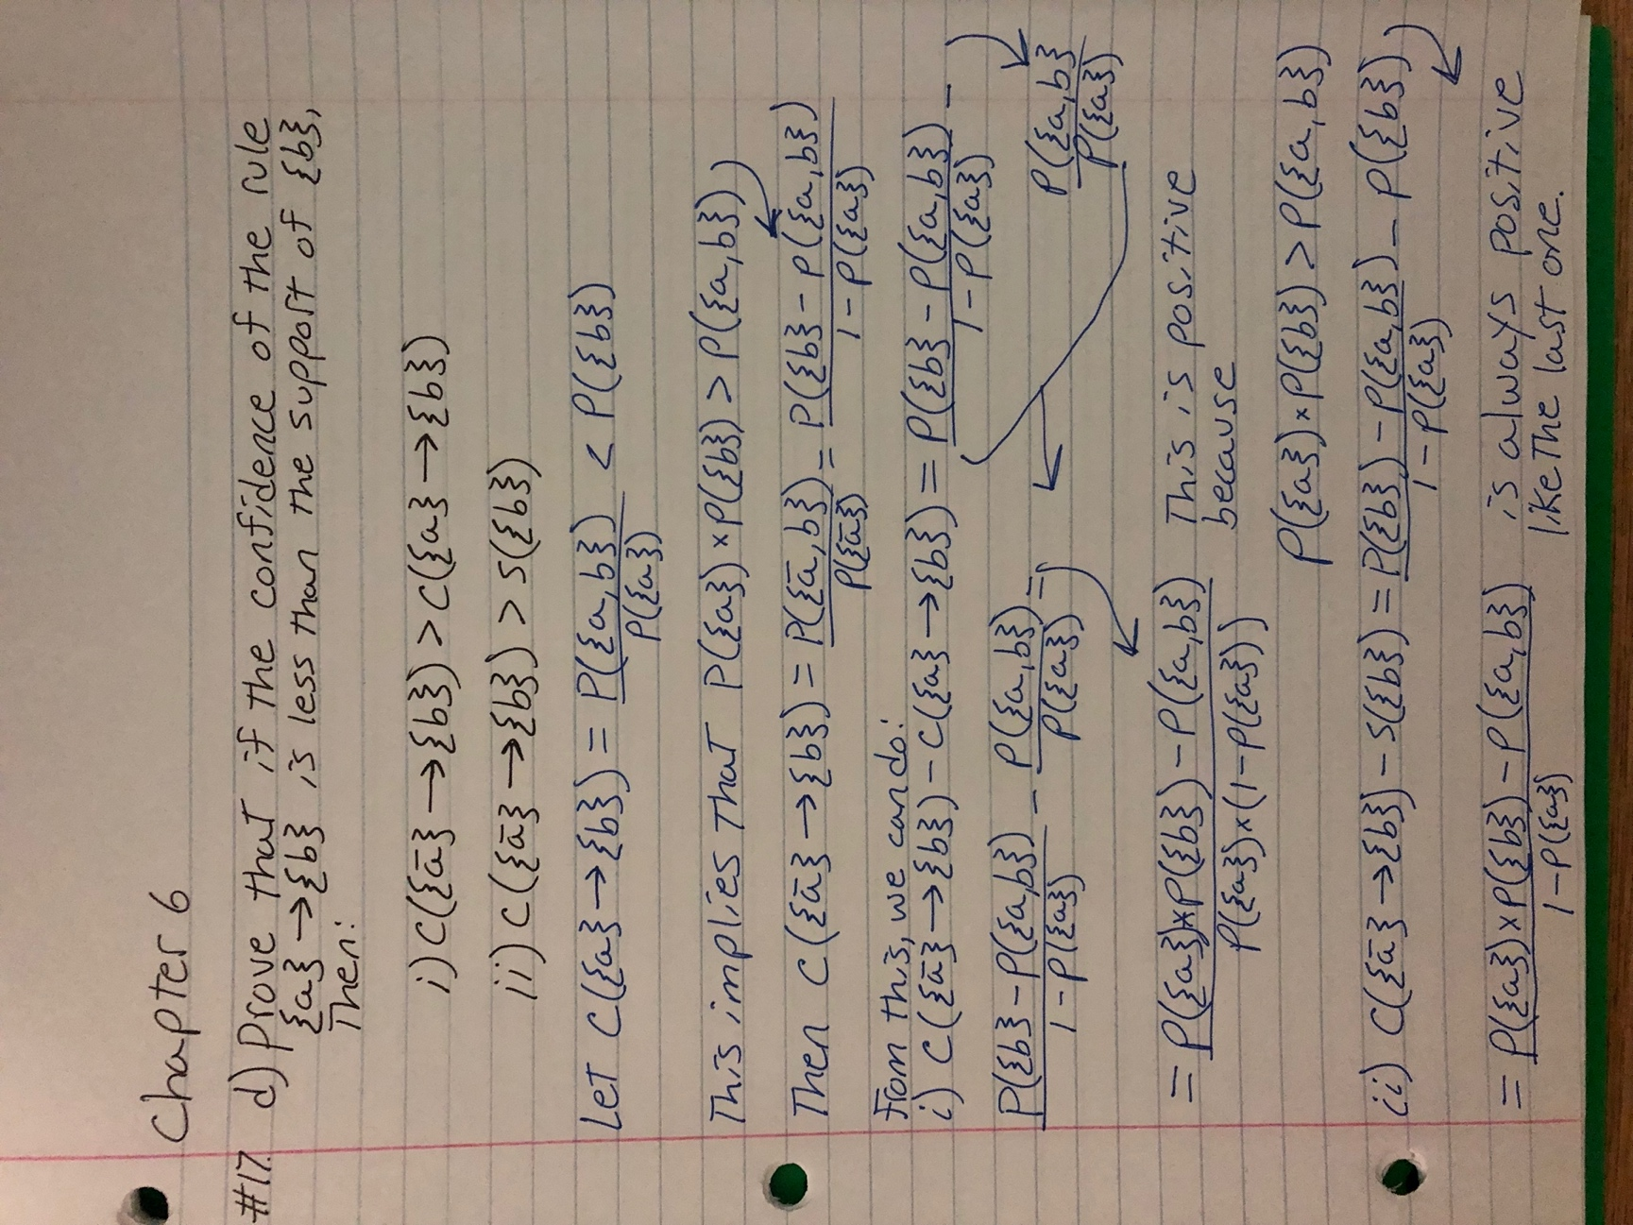

Chapter 7:
#6) Consider the data set shown in table 7.13. Suppose we are interested in extracting the following association rule:
{$α$₁$≤Age≤α$₂, Play Piano = Yes} {Enjoy Classical Music = Yes}
Age | Play Piano | Enjoy Classical Music
9 | Yes | Yes
11 | Yes | Yes
14 | Yes | No
17 | Yes | No
19 | Yes | Yes
21 | No | No
25 | No | No
29 | Yes | Yes
33 | No | No
39 | No | Yes
41 | No | No
47 | No | Yes

To handle the continuous attribute, we apply the equal-frequency approach with 3, 4, and 6 intervals. Categorical attributes are handled by introducing as many new asymmetric binary attributes as the number of. Categorical values. Assume that the support threshold is 10% and the confidence threshold is 70%.
- Suppose we discretize The Age attribute into 3 equal-frequency intervals. Find a pair of values for $α$₁ and $α$₂ that satisfy the minimum support and minimum confidence requirements.
There are 12 Age values. Discretize the Age attribute into 3 equal-frequency intervals gives 3 groups of 4 values each.
{9, 11, 14, 17}, {19, 21, 25, 29}, {33, 39, 41, 47}
$α$₁ = 19
$α$₂ = 29
Support = 16.7%
Confidence = 100%
- Repeat part (a) by discretizing the Age attribute into 4 equal-frequency intervals. Compare the extracted rules against the ones you had obtained in part (a).
There are no rules that satisfies the support and confidence thresholds set.
- Repeat part (a) by discretizing the Age attribute into 6 equal-frequency intervals. Compare the extracted rules against the ones you had obtained in part (a).
There are 12 Age values. Discretize the Age attribute into 6 equal-frequency intervals gives 6 groups of 2 values each.
{9, 11}, {14, 17}, {19, 21}, {25, 29}, {33, 39}, {41, 47}
$α$₁ = 9
$α$₂ = 11
Support = 16.7%
Confidence = 100%
- From the results in part (a), (b), and (c), discuss how the choice of discretization intervals will affect the rules extracted by the association rule mining algorithms.
If the discretized interval is too wide then some of the rules may not have enough confidence to be detected by the algorithm, or if the interval is too narrow, the interval may not have enough support and the rule declared in part (a) would be lost.

